

Year 10 Science

Earth & Space 2 Test: The Universe

SECTION 1: MULTIPLE CHOICE (1 mark each)

Circle your answer on the multiple choice answer sheet.

- Which is the correct order from smallest to largest?
  - Moon, star, planet, asteroid.
  - Moon, planet, galaxy, universe.
  - Comet, meteor, galaxy, star.
  - Sun, moon, galaxy, universe.

- What is the order of planets in our solar system?
  - Sun, Venus, Mercury, Earth, Mars, Saturn, Jupiter, Uranus, Neptune.
  - Sun, Mercury, Venus, Earth, Mars, Jupiter, Saturn, Uranus, Neptune
  - Sun, Mercury, Venus, Earth, Saturn, Mars, Jupiter, Neptune, Uranus
  - Sun, Mercury, Venus, Earth, Mars, Saturn, Jupiter, Uranus, Neptune

- What is our galaxy called?
  - Milky Bar.
  - Milky Sign
  - Milky Way
  - Milky Star

- The gravitational field of a black hole is so strong that not even light is fast enough to escape from it.
  - True.
  - False.

- Which of the following is true about the Big Bang Theory?
  - Galaxies are moving apart from each other as the universe expands.
  - Stars are being thrown apart from each other due to the momentum of a past explosion.
  - The universe suddenly appeared in space.
  - The Big Bang attempts to explain why the universe was created, what existed before the universe and what exists outside of the universe.

- A device that is used to analyse starlight is called?
  - Spectrometer
  - Speed-gun
  - Spectrum meter
  - Spectrometer analyser
- Which of the following is not evidence for the Big Bang Theory?
  - The universe continues to expand, as measured using Doppler Effect and spectral shift analysis.
  - There is an abundance of hydrogen and helium, the first two elements to exist in the universe, at levels predicted by Big Bang Theorists.
  - Cosmic microwave radiation exists uniformly in the universe as background radiation, at levels predicted by the Big Bang theorists.
  - The Square Kilometre Array has detected hadrons and measured gravity waves which show the existence of black holes, as predicted by Big Bang Theorists.

- In spectral analysis of stars, red shift occurs
  - as apparent wavelength increases.
  - as a star moves towards us.
  - as apparent frequency increases.
  - as apparent temperature increases.

- The source of energy for our star is
  - nuclear fission of helium to form hydrogen.
  - nuclear fusion of hydrogen to form helium
  - combustion of hydrogen and helium
  - nucleosythesis of protons and neutrons to form hydrogen

- Our sun is a medium star. It will become all of the following during its lifetime, except a
  - red giant.
  - planetary nebula
  - white dwarf
  - neutron star

- Which is the correct sequence for the life cycle a very large star
  - Stellar nebula → massive star → red hypergiant → supernova → black hole
  - Planetary nebula → White dwarf → red hypergiant → supernova → Pulsar
  - Stellar nebula → massive star → red hypergiant → supernova → Planetary nebula
  - Stellar nebula → massive star → blue ghost giant → supernova → black hole

- List in order the least dense to most dense
  - Nebula, Earth, Black-hole.
  - Black-hole, Earth, Nebula.
  - Earth, Black-hole, Nebula
  - Earth, Nebula, Black-hole

Examine the Hertzsprung-Russell Diagram and then answer the questions below

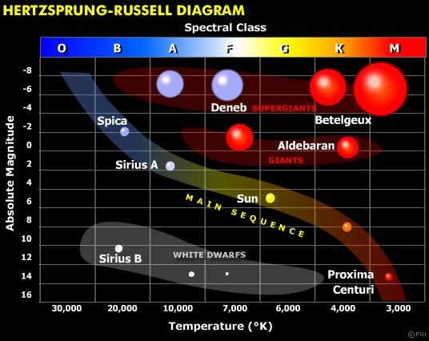

- What is the absolute magnitude of a white dwarf?
  - 2
  - 14
  - 7,000
  - 10,000

- Which of these stars is in the M spectral class?
  - Aldebaran
  - Proxima Centauri
  - Betelgeux
  - Sirius M

- Which star would be described as yellow, medium sized, medium temperature and middle aged?
  - Our sun
  - Deneb
  - Sirius A
  - Spica

END OF TEST

